Information Security (BDS-7A)  Quiz 02 (Fall 2024). Instructor: Dr. Syed M. Irteza |  | Name: SOLUTION
Date: 2024-09-30 |  | Roll Number:
Total Marks: 10 | Time Allowed: 8 mins

- Describe how prefix-postfix MAC is different from a hash-based MAC: (3 marks)

With prefix-post MAC, we can skip encryption completely. We simply prepend and append the key to the message, then take a hash of the complete content, and then use this digest as the MAC.

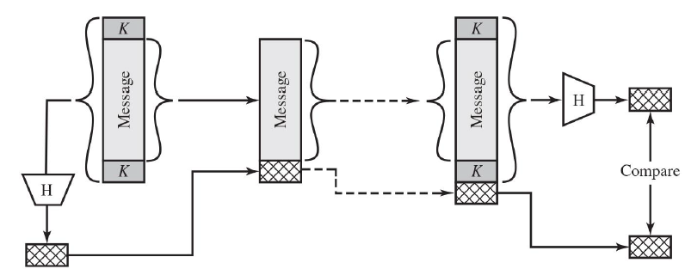

With hash-based MAC, we perform both a hash and an encryption (using a secret key).

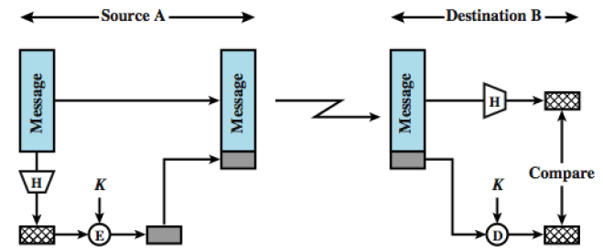

- Describe three properties that are required within cryptographic hash functions? (3 marks)

Any three of the following:
- Output is a pseudo-random combination of 1’s and 0’s distributed variably with a proportion of 50% each
- Given a hash function ℎ and a digest 𝑦, it must be extremely difficult for Eve (attacker) to find any message, M’, such that 𝑦 = h(M’)
- Given a specific message and its digest, it must be extremely difficult to create another message with the same digest.
- Eve cannot find two messages (from scratch) that hash to the same digest.

- Hash functions produce _______ and have _______ size inputs and ____ sized outputs: (2 marks)
  - MAC; fixed; variable
  - message digests; variable; fixed
  - MAC; variable; fixed
  - message digests; fixed; variable

- What property of hash functions make collisions unavoidable? (2 marks)
  - They are one-to-many functions
  - They are reversible
  - They produce random output
  - They are many-to-one functions

